**Cats and brands…**

*One study inside another...*

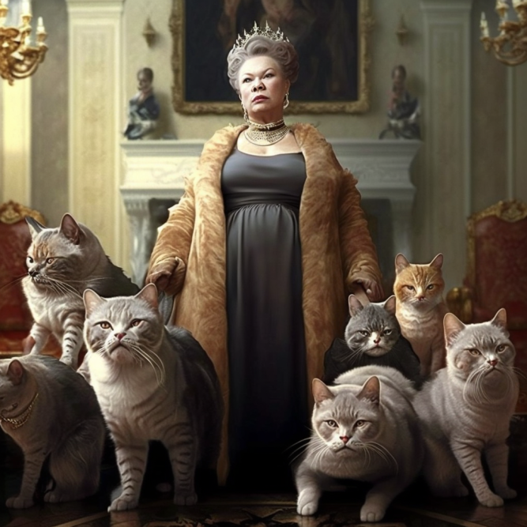

*«Russian oligarch with 7 cats». Mid Journey. Mixed media 2023.*

Greetings everyone! It’s [Wellhead](https://wellhead.ru/projects/magnit-obraz-zhizni/).

In our ordinary life we create and work with the best and coolest FMCG-brands, however today we want to be naughty. Just like Karlsson or like Marauders.

Straightaway we want to say thank you to [«ЛебедяньМолоко»,](https://lmilk.ru/) the research was made for their project. And we are really excited that they agreed to publish this article.

The survey was quantitative, there were about 400 recipients. The main questions, were of course about the project, but we added several of them about pets and their amount. And it was rather interesting.

That is a great time to give a shout out to [Tiburon](https://tiburon-research.ru/) for an amazing platform for surveys, which is ideal for the targeted audience and the further analysis. All the following charts are the print screens of their online report.

And also, we are thankful for the AI Midjourney for providing the illustrations of his ~~wild~~ mechanic imagination.

**Cats and real life.**

Let’s start from the beginning. We mostly focused on the consumers of dairy products in different regions of Russia. And also questioned them about their pets.

As we can see the leader is a male or female species of cats. More over…

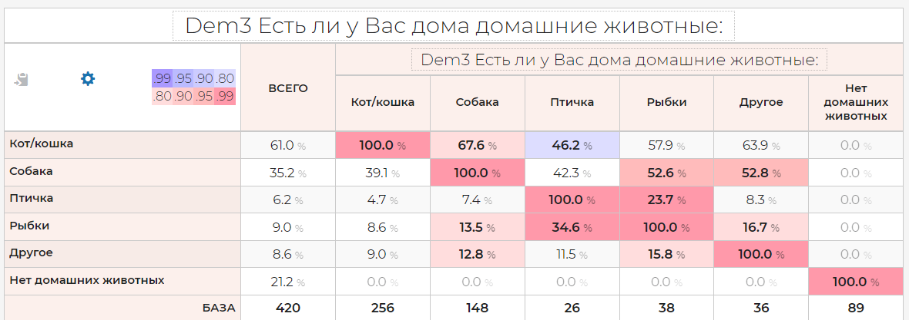

Cats are self-sufficient animals.

They don’t need anyone, only the man who feed them. That is why only 40% of cat owners also have a dog, or other pets, which are even smaller in size.

On the other hand people, who love dogs, also love cats. ⅔ of dog owners also own a cat. And fish. And birds. They don’t limit the amount of their pets.

The owners of fish don’t get embarrassed by cats, more over half of the respondents have them. However if a person loves cast, he doesn’t have any love towards fish. And that’s right. The cat can drown. Cat is not a fish.

The bird owners are careful towards cats and rarely get them. But they also can’t resist towards them.

And only 21% of respondents don’t own any pets.

What about kids? Does the existence of kids affect having cats?

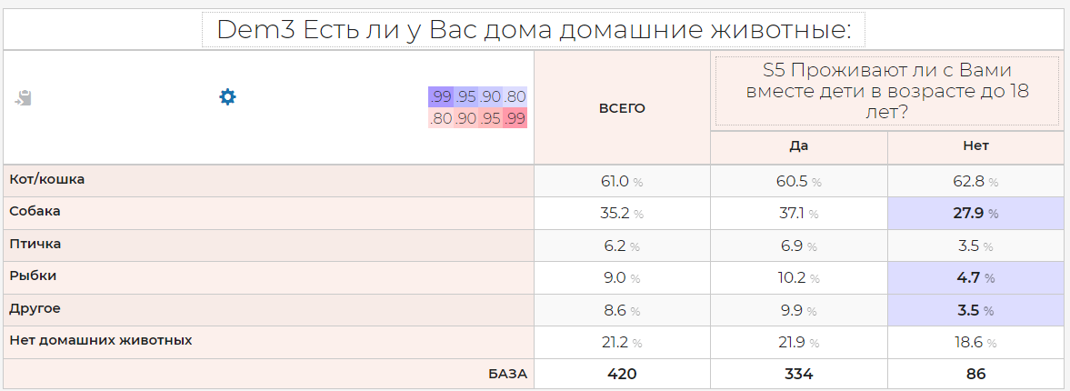

Spoiler, it doesn’t. However it does affect having dogs, fish and others (may it be the immortal hamsters). As we’ve remembered, Kid wanted a dog, not a cat… But the majority receive not a fluffy friend, but fish or other small rodents.

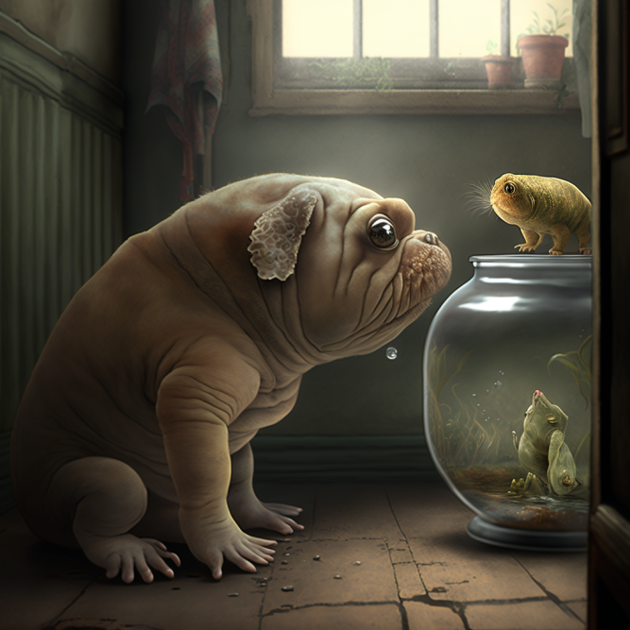

*«Others. Homestay». Mid Journey, mixed media, 2023.*

Pets are also affecting the life values.

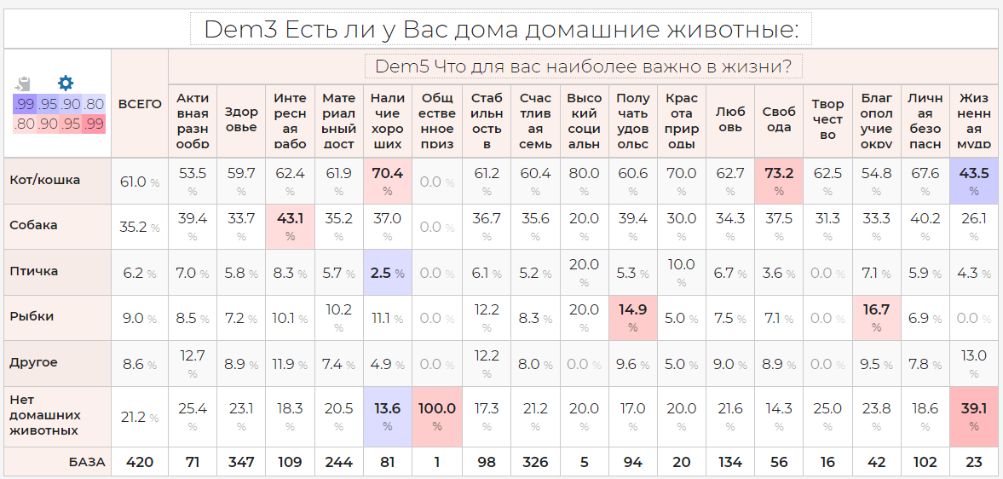

Especially the lack of pets affects the life values of person: person is busy with comprehension of life values. There is no time for cats, of course.

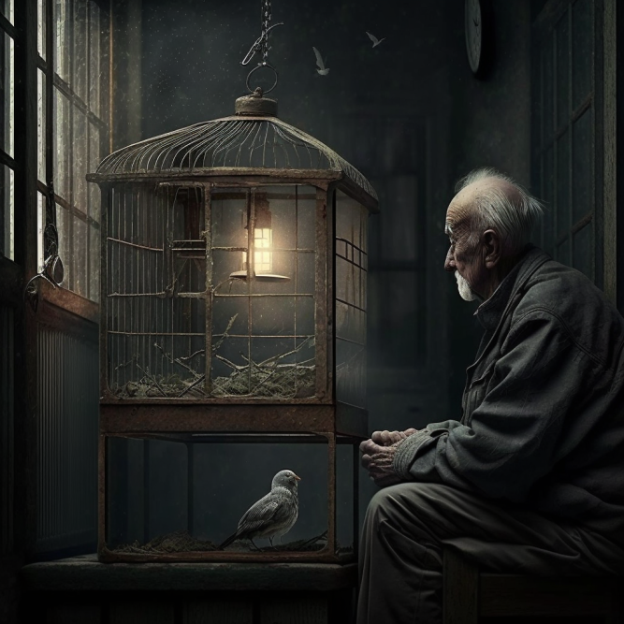

*«The comprehension of wisdom in Russia». Mid journey, mixed media, 2023.*

The ones who have cats, especially value good friends and freedom. However the bird owners don’t need any friends. And the dog owners much rather prefer to work.

Actually, people in Russia are shy. Only one respondent confessed that he values the public acceptance, and five others - high social status. Are they cunning?

Not that popular: arts, life wisdom and well-being of others. Freedom is valid for only 13% (The survey took place in October of 2022).

At the top, as we expected: health, well-being of family members and being wealthy.

Interesting job disturbs only every fourth, just like enjoyment of life.

Let’s focus on the most thrilling question: does having cats affect the love towards brands with cat images in any way?

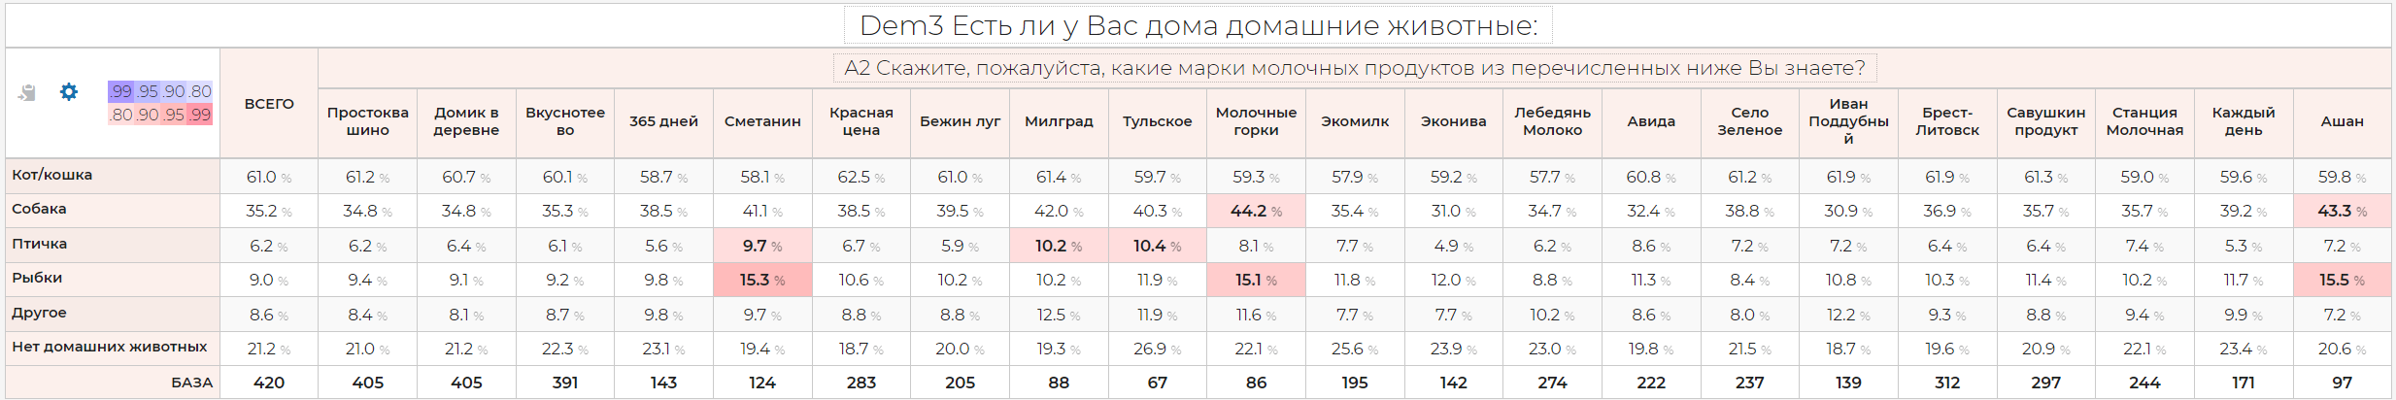

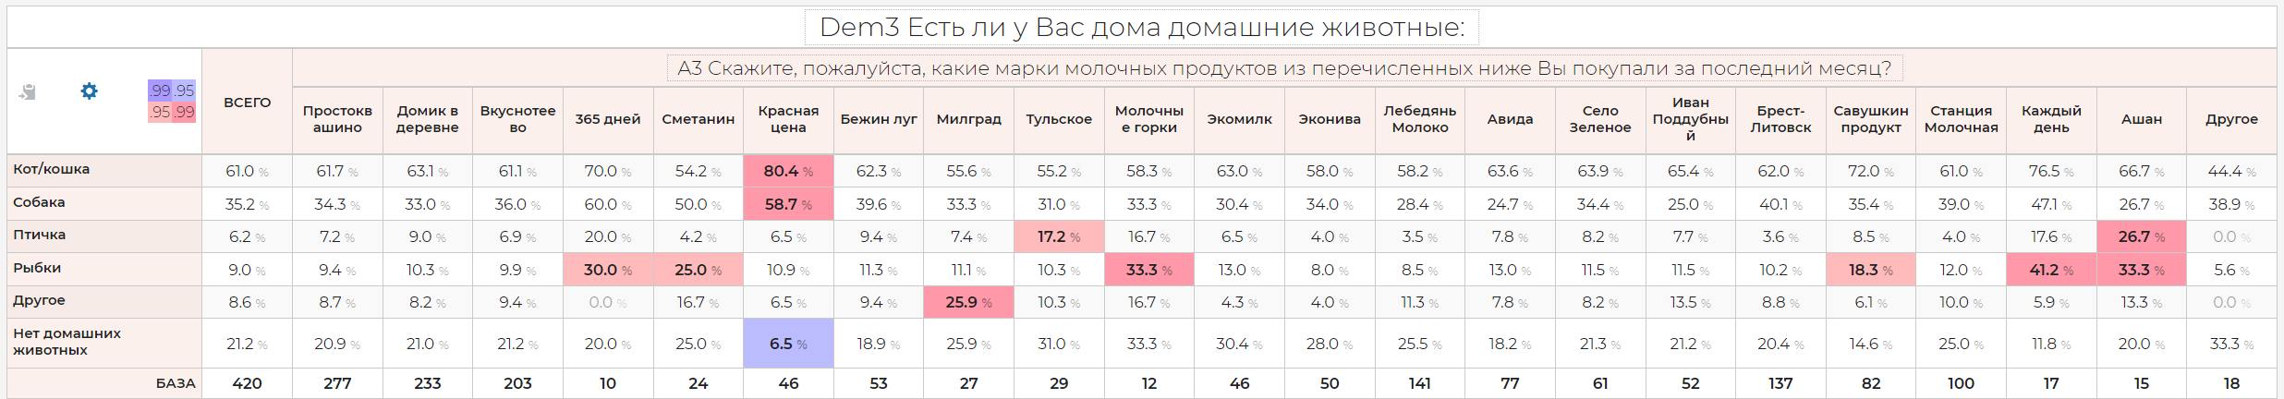

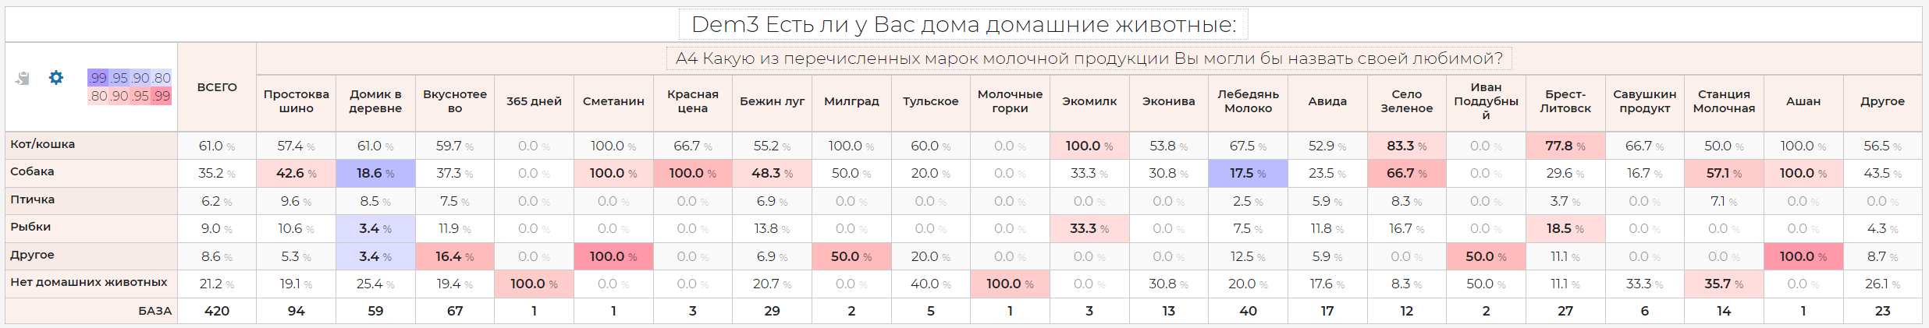

And here there is a big disappointment: cats owners don’t allocate brands with cats(Простоквашино, Милград) from the total weight. Pets don’t really affect the choice of brands.

Thus, the thesis that the picture of a cat on the package affects the sales is quite controversial.

Dairy products and cats are loved on their own.

What about the consumer behavior of cat owners?

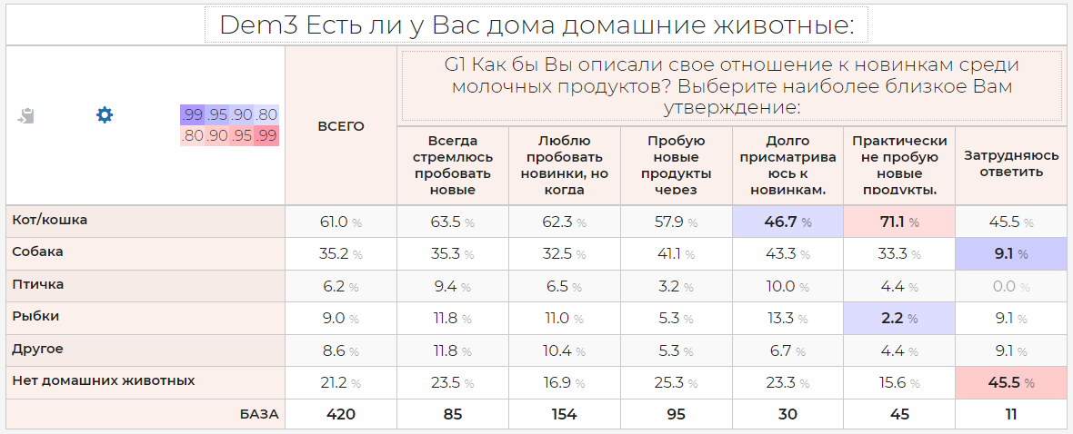

Nothing special, there are some deviations in the caution sector, but it’s a small amount of respondents. It’s hard to make any assumptions.

The wealth of cat owners is average, like everyone else.

But having a dog is a mark for wealthy people, just like having birds and fish.

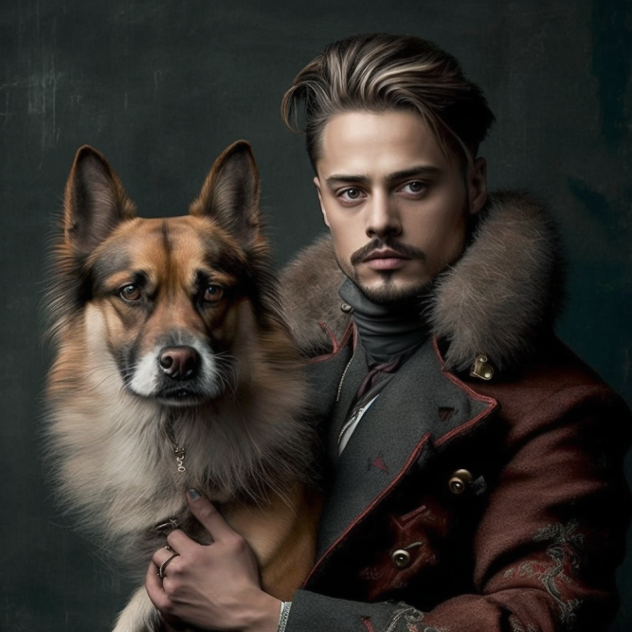

*«Wealthy Russian with his dog». Mid journey, mixed media, 2023.*

P.S. During this research no animals (even humans) were harmed.